
Department of Mechanical Engineering

EMCH 368
MECHATRONICS

Lab 09
LED Classification

Last Edited: 06/11/23 by J. Vaught

Exercise 1: Building the Circuit:
This lab utilizes MATLAB to create a means by which to classify an LED as either red or green. To do this, a linear classifier was programmed to develop a way to differentiate the two LEDs within MATLAB. Once a method to do so is obtained, we utilized Arduino to actually deploy the classification method. It sounds complicated, but basically we used MATLAB to figure out the difference between red and green LEDs, and based on the difference recorded, we then incorporated this into an Arduino program.

Materials:
- (1) Set of long red and black jumper wires
- (2) 220-ohm resistor
- (1) Red LED
- (1) Green LED
- (2) Potentiometers

Building the Circuit:
- Connect a red wire to the 5V pin on the Arduino and put the other end in one of the long (+) bus lines in the breadboard.
- Connect a black wire to the ground pin on the Arduino to the adjacent long (-) bus line on the breadboard.
- Connect two potentiometers to the breadboard with one leg connected to power and the other connected to ground. Connect the middle pin of one to A0 and the middle pin of the second to A1.
- Connect one red and one green LED to your bread board.
- Connect the anode (long leg) of the red LED to digital pin 3 and the cathode (short leg) to ground.
- Connect the anode of the green LED to digital pin 2 and ground the cathode as well.
- Connect the Arduino to power by connecting it to your computer through USB.
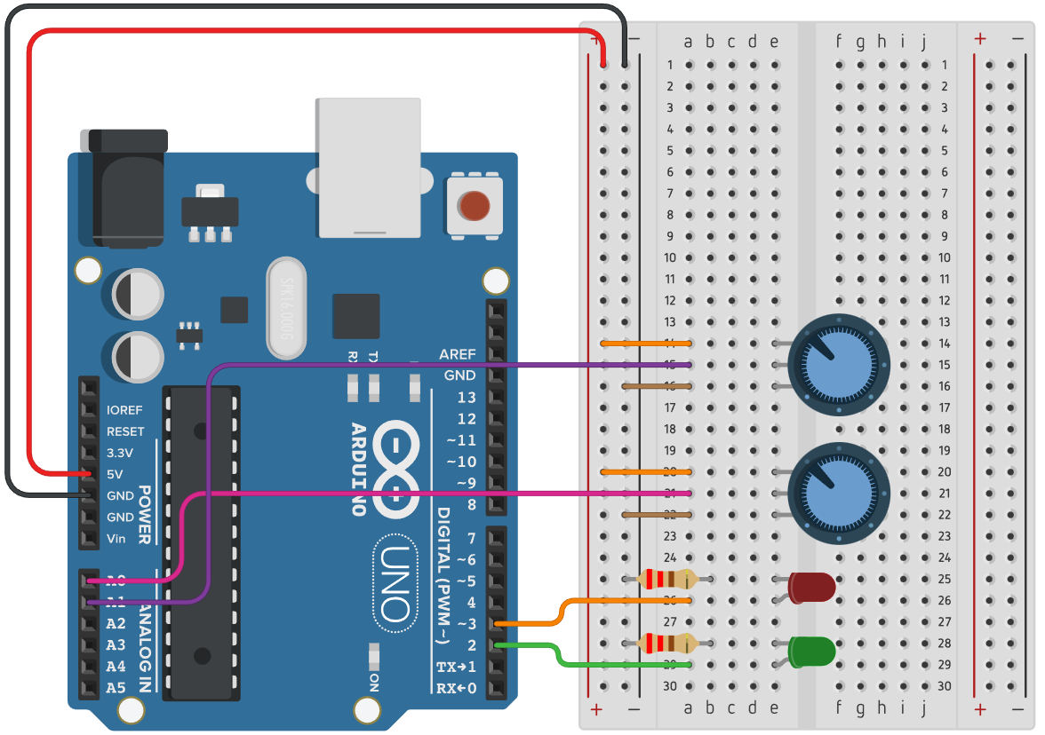
Exercise 1 Circuit
Writing the Code (Part 1):
Open MATLAB to write the training portion of this code. The goal of this code is to create a way by which to classify the color of an LED on the Arduino. Once the MATLAB script is run, a graph will be output which will give us a way to distinguish between the LED’s based on the input voltage. (R2020b is used in this demo however, no specific add-ons are required so this should work for most recent distributions ~ >2017)

This will simply clear any script or workspace you have set up within MATLAB, allowing you to start the new program from scratch.

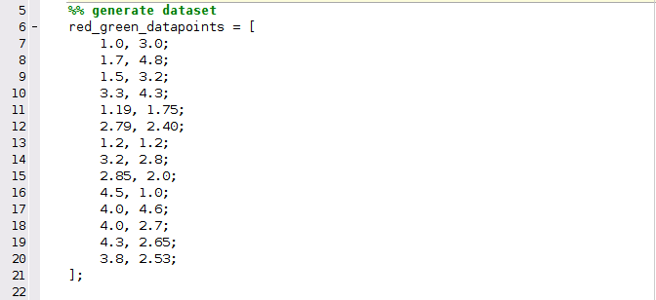

Within this code, example data points that represent 2 different voltage values were created within this matrix. This gives the MATLAB program data to sort through and classify as either “red” or “green” in this case.

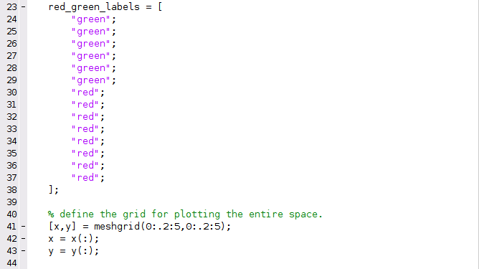
This section labels the previously input data points as either red or green on the graph we will have output. To output this graph, the meshgrid

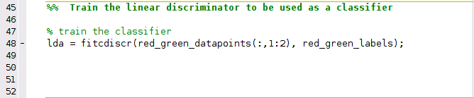
The fitcdiscr() function in MATLAB is a built-in classifier function. The purpose of this code is to return a fitted discriminant analysis model based on the input variables red_green_datapoints and the output contained in red_green_labels. The first argument of the fitcdiscr() function is described as either a predictor, feature or attribute, while the second argument is a response or label.
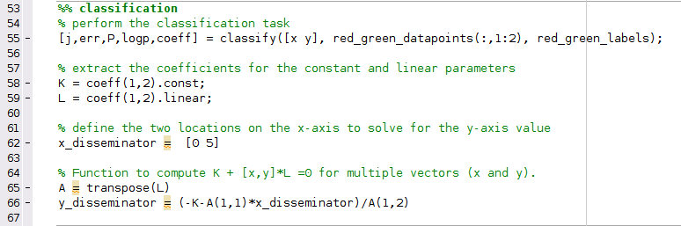
This is the classification portion of the code. The syntax of the first function can be seen as classify(sample, training, group). A few things to keep in mind with the classify function is the sample and training data sets must be matrices with the same number columns. Inversely, the training and group data sets must have the same number of rows. [j, err, P, logp, coeff] is a built in MATLAB function to obtain more data using classify. Err returns an estimate of the error rate based on misclassification of the training data. P returns a matrix posterior of estimates of the posterior probabilities that the nth training group was the source of the i’th sample observation. Logp returns a vector containing estimates of the logarithm of predictive probability density of the example observations. Lastly, coeff returns an array containing coefficients of the boundary curves between pairs of groups.
After the classification, an x_disseminator and a y_disseminator were determined. The output of each disseminator is a range on the x or y-axis and with these, a line can be drawn which will determine if a data point represents red or green.

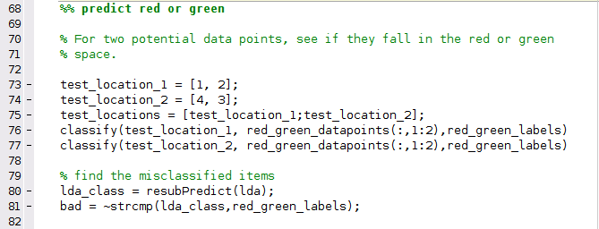
Two potential data points are classified to see if they fall within either red or green. With test_location_1 and test_location_2 classified, the resubPredict function was used on the previously classified data set lda, which simply returns the predicted label for the training data. The newly classified test locations stored in the array lda_class was then compared to red_green_labels using the ~strcmp function, which compares strings. This is done to find any misclassified data, such as if a data point was labeled red, but placed in green, the strings that label the points would not be equal and signal a misclassification.

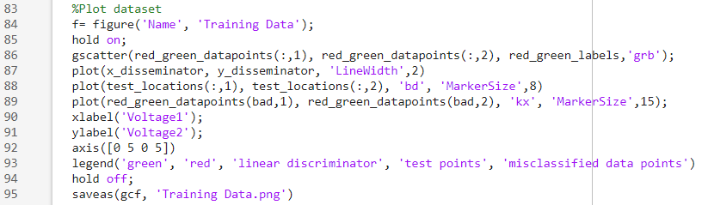
This section of code will provide information to the grid we created previously. While it is a bit of code, it is not necessarily technical, but for more in depth plotting help, you can search “plot” in MathWorks and take the whole day seeing your options.

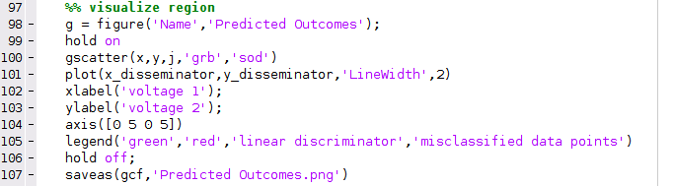
This visualization section gives us the outputs seen below; the graph representing the training data classification period as well as a graph of the predicted outcomes based on the linear model developed.
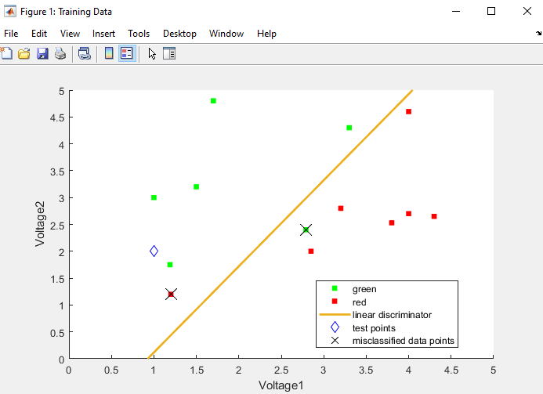
Figure 1: Training Data Classification Graph
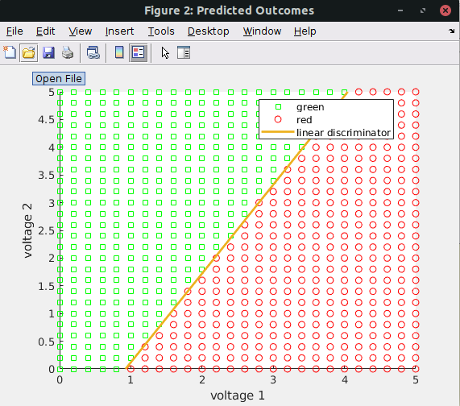
Figure 2: Predicted Outcomes Graph
The output of the Matlab script will give you two graphs, one depicting the training data being classified and the other the overall predicted outcomes based on the classifier. The graph showing the training data also includes the misclassified and subsequently excluded data points that were incorrectly labeled as either red or green.
The main objective of these graphs is depicted by the linear discriminator, which is the line between the points (0,-1.4846) and (5, 6.5289), or the values obtained and labeled as our x and y disseminators from the MATLAB script. To classify an LED on our Arduino, we will use the equation of a line, y=mx+b, where m is the slope of the linear discriminator, b is the y-intercept of the linear discriminator, x is voltage 1 from the figure above and y is voltage 2. We can then program this equation into Arduino when we are ready to deploy this classifier.
Writing the Code (Part 2):
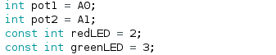
These variables will not change throughout the code, so they are being declared before the void setup.
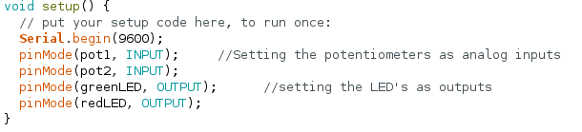
Within the setup, the serial monitor is initialized, as well as the potentiometer pins set as inputs and the LED pins set as outputs.
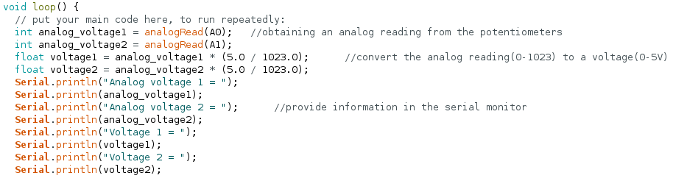
This section reads the analog value obtained from the potentiometer. With this value, a voltage is obtained by multiplying the analog values by 5/1023. This gives us two voltage values, voltage1 and voltage2, and these are required to plug into the equation of the line obtained from the MATLAB output.
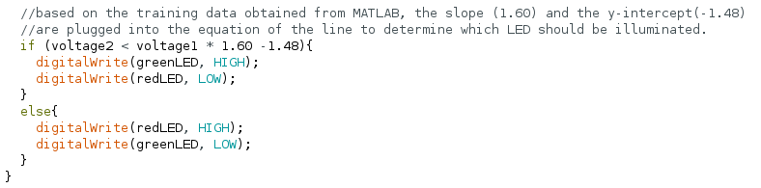
The if statement is simply saying if voltage2 is less than voltage1 times the slope obtained from MATLAB minus the y-intercept, the LED should light up green, and inversely, if voltage2 is greater than the other side of the equation, the red LED should illuminate.
You can look at your final result basically as follows. Voltage1 and Voltage2 together make up a point on the predicted outcomes graph from MATLAB. These points are obtained by converting the analog value read from the potentiometer to a voltage value. If the point on the graph that you have obtained is above the line on the predicted outcomes graph, the LED will light up green, and if the point falls below the line, the LED will light up red.

Lab Grading Rubric:
- Circuit fully built (20 points)
- Training data graph (15 points)
- Predicted outcomes graph (15 points)

